**REAL TIME DETECTION BY VIDEO PROCESSING USING DEEP NEURAL NETWORK FOR ATTENDANCE SYSTEM**

**Project report in partial fufilllment of the requirement for the award of the degree of**

**Bachelor of Technology**

**In**

**COMPUTER SCIENCE & ENGINEERING**

**Submitted By**

ANKIT GUPTA University Roll No. 3312015009001312

AJAY SINGH GORWA University Roll No. 3312015009001301

PRINCE BARAI University Roll No. 3312015009001439

MD. HUSSNAIN University Roll No. 3312015009001317

RUDRA SADHU University Roll No. 3312015002001037

**Under the guidance of**

PROF. SHANKHADEEP CHATTERJEE

Department of Computer Science & Engineering



UNIVERSITY OF ENGINEERING & MANAGEMENT, KOLKATA

University Area, Plot No. III – B/5, New Town, Action Area – III, Kolkata – 700160

**ACKNOWLEDGEMENT**

We would like to take this opportunity to thank everyone whose cooperation and encouragement throughout the ongoing course of this project remains invaluable to us.

We are sincerely grateful to our guide Prof. Sankhadeep Chatterjee of the Department of Computer Science & Engineering, UEM, Kolkata, for his wisdom, guidance and inspiration that helped us to go through with this project and take it to where it stands now.

We would also like to express our sincere gratitude to Prof. SukalyanGoswami, HOD, Computer Science & engineering, UEM, Kolkata and all other departmental faculties for their ever-present assistant and encouragement.

Last but not the least, we would like to extend our warm regards to our families and peers who have kept supporting us and always had faith in our work.

Ankit Gupta

Ajay Singh Gorwa

Prince Barai

Md. Hussnain

Rudra Sadhu

**TABLE OF CONTENTS**

**Abstract**

1. **Introduction**
   1. **Overview**
   2. **Problem definition**
   3. **Objectives**
   4. **Scope of the project**
   5. **Justification**
2. **Face Detection**
   1. **Introduction**
   2. **Segmentation based on color**
      1. **RGB Color Space**
      2. **HSV Color model**
   3. **Proposed Approach**
3. **Face Recognition**
   1. **Introduction**
   2. **PCA**
   3. **Neural Network As A Recogniser**
4. **Methodology & System design**
   1. **System design**
   2. **General Overview**
   3. **Training Set Manager Sub system**
   4. **Face Recognizer Sub System**
   5. **System Architecture**
   6. **Functions of two Sub System**
5. **Experimental Screenshot**
6. **Attendance Registering**
   1. **Introduction**
   2. **Creating Attendance Sheet**
   3. **Marking Attendance of the student**
7. **Conclusion**
8. **Future Work**
9. **References**

**ABSTRACT**

Uniqueness or individuality of an individual is his face. In this project face of an individual is used for the purpose of attendance making automatically. Attendance of the student is very important for every college, universities and school. Conventional methodology for taking attendance is by calling the name or roll number of the student and the attendance is recorded. Time consumption for this purpose is an important point of concern. Assume that the duration for one subject is around 60 minutes or 1 hour & to record attendance takes 5 to 10 minutes. For every tutor this is consumption of time. To stay away from these losses, an automatic process is used in this project which is based on image processing. In this project face detection and face recognition is used. Face detection is used to locate the position of face region and face recognition is used for marking the understudy’s attendance. The database of all the students in the class is stored and when the face of the individual student matches with one of the faces stored in the database then the attendance is recorded.

**1. Introduction**

**1.1 Introduction to Real time detection by video processing using deep neural network for attendance system**

Maintaining attendance is very important in all learning institutes for checking the performance of students. In most learning institutions, student attendances are manually taken by the use of attendance sheets issued by the department heads as part of regulation. The students sign in these sheets which are then filled or manually logged in to a computer for future analysis. This method is tedious, time consuming and inaccurate as some students often sign for their absent colleagues. This method also makes it difficult to track the attendance of individual students in a large classroom environment. In this project, we propose the design and use of a face detection and recognition system to automatically detect students attending a lecture in a classroom and mark their attendance by recognizing their faces.

While other biometric methods of identification (such as iris scans or fingerprints) can be more accurate, students usually have to queue for long at the time they enter the classroom. Face recognition is chosen owing to its non-intrusive nature and familiarity as people primarily recognize other people based on their facial features. This (facial) biometric system will consist of an enrollment process in which the unique features of a persons’ face will be stored in a database and then the processes of identification and verification. In these, the detected face in an image (obtained from the camera) will be compared with the previously stored faces captured at the time of enrollment.

**1.2 Problem Definition**

The traditional manual methods of monitoring student attendance in lectures are tedious as the signed attendance sheets have to be manually logged in to a computer system for analysis. This is tedious, time consuming and prone to inaccuracies as some students in the department often sign for their absent colleagues, rendering this method ineffective in tracking the students’ class attendance. Use of the face detection and recognition system in lieu of the traditional methods will provide a fast and effective method of capturing student attendance accurately while offering a secure, stable and robust storage of the system records, where upon authorization; one can access them for purposes like administration, parents or even the students themselves.

**1.3 Objectives**

The overall objective is to develop an automated class attendance management system comprising of a desktop application working in conjunction with a mobile application to perform the following tasks:

* To detect faces real time.
* To recognize the detected faces by the use of a suitable algorithm.
* To update the class attendance register after a successful match.
* To design architecture that constitutes the various components working harmoniously.

**1.4 Scope of the project.**

We are setting up to design a system comprising of two modules. The first module (face detector) is a mobile component, which is basically a camera application that captures student faces and stores them in a file using computer vision face detection algorithms and face extraction techniques. The second module is a desktop application that does face recognition of the captured images (faces) in the file, marks the students register and then stores the results in a database for future analysis.

**1.5 Justification.**

This project serves to automate the prevalent traditional tedious and time wasting methods of marking student attendance in classrooms. The use of automatic attendance through face detection and recognition will increase the effectiveness of attendance monitoring and management.

This method could also be extended for use in examination halls to curb cases of impersonation as the system will be able to single out the imposters who won’t have been captured during the enrollment process. Applications of face recognition are widely spreading in areas such as criminal identification, security systems, image and film processing. The system could also find applications in all authorized access facilities.

**2. Face Detection**

**2.1 Introduction**

Face detection is defined as finding the position of the face of an individual. In other word it can be defined as locating the face region in an image. After detecting the face of human its facial features is extracted and has wide range of application like facial expression recognition, face recognition, observation systems, human PC interface and so forth…Detecting face in an image of single person is easy but when we consider a group image of an image containing multiple faces, the task becomes difficult.

For the application of face recognition, detection of face is very important and the first step. After detecting face the face recognition algorithm can only be functional. Face detection itself involves some complexities for example surroundings, postures, enlightenment etc.

There are some existing methodologies for detection of face. Some of them are skin color based, characteristic or feature based (feature like mouth, nose and eyes) and neural network based. Among the above techniques, the skin based procedure is well thought-out as simplest one. The approach premeditated and applied in this thesis is the skin color based face detection method. The algorithm is pretty dynamic as numerous people face can be detected at one time from an image containing many people.

**2.2 Segmentation based on color**

The Segmentation can be defined as the conception of subdividing a given image into its constituent region. Segmentation based on the color of skin is picking up its supremacy in current time. Skin based segmentation is being studied for the reason that of its dynamic research in content- based picture illustration. In the case of face detection, segmentation is used to find locate the face boundary of face region in an image. Once the face region is found, we can apply various processing like image editing, various coding, and image indexing and client intuitiveness intention. Moreover, face detection is the first step required for the purpose of recognition of face and its expression using various processes. Color of Skin of an individual depends on various biochemical components like the melanin content, pigmentation of skin and much more. The skin color is belongs to certain range in the total color space. Consideration should be taken into account that the skin should not be abnormal. Used algorithm in this project takes the benefit of face color association to limit the face search to areas of an input image that have at least the accurate color components. There are many existing algorithm for segmentation but used algorithm is the simplest one.

**2.2.1 RGB Color Space**

Red, green, blue are the three color component that constitute the RGB color space. These red, green, and blue colors combine in a definite proportion to yield a different color. RGB color model can be represented by a 3-dimentional cube with the three colors at the corner of the cube and in each axis as shown in Figure. At the origin of this cube black color is present. White color is present at the opposite corner of the 3-dimesional cube i.e., at the opposite diagonal of the cube. Gray color scale is represented by the line from black color at the origin to the white color at opposite corner. Red is (255, 0, 0) when we consider a 24-bit color graphics system with a color bit of 8-bit per color channel. When we consider the 3-dimensional color cube, red is at (1, 0, 0). This model simplifies the design of the pc graphics frameworks yet is not perfect for all type of application applications. These three color component are very closely related to each other, which makes it hard to implement some of the algorithm for image processing.

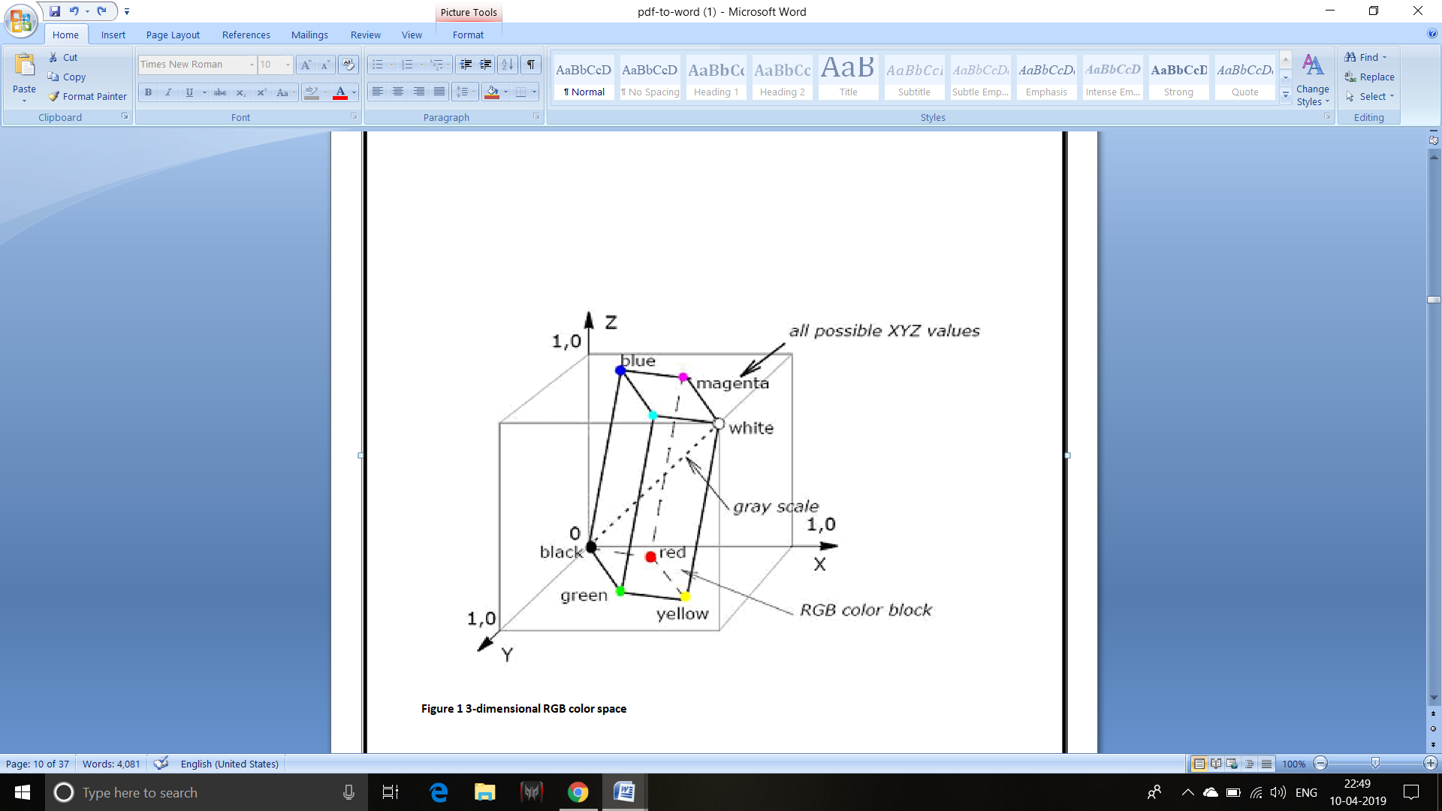

**2.2.2 HSV Color Model**

There are some problems which are associated with the RGB color space model. One important issue connected with RGB is that it doesn’t consider the effect of light on the color of skin, which generally cause some wrong in turn. This problem can we solved by using HSV model for skin color. Here H stand for hue which is depth of color, S stand for saturation or the purity of color and V stand for the value of intensity of light or the brightness of color. The model is shown in figure.

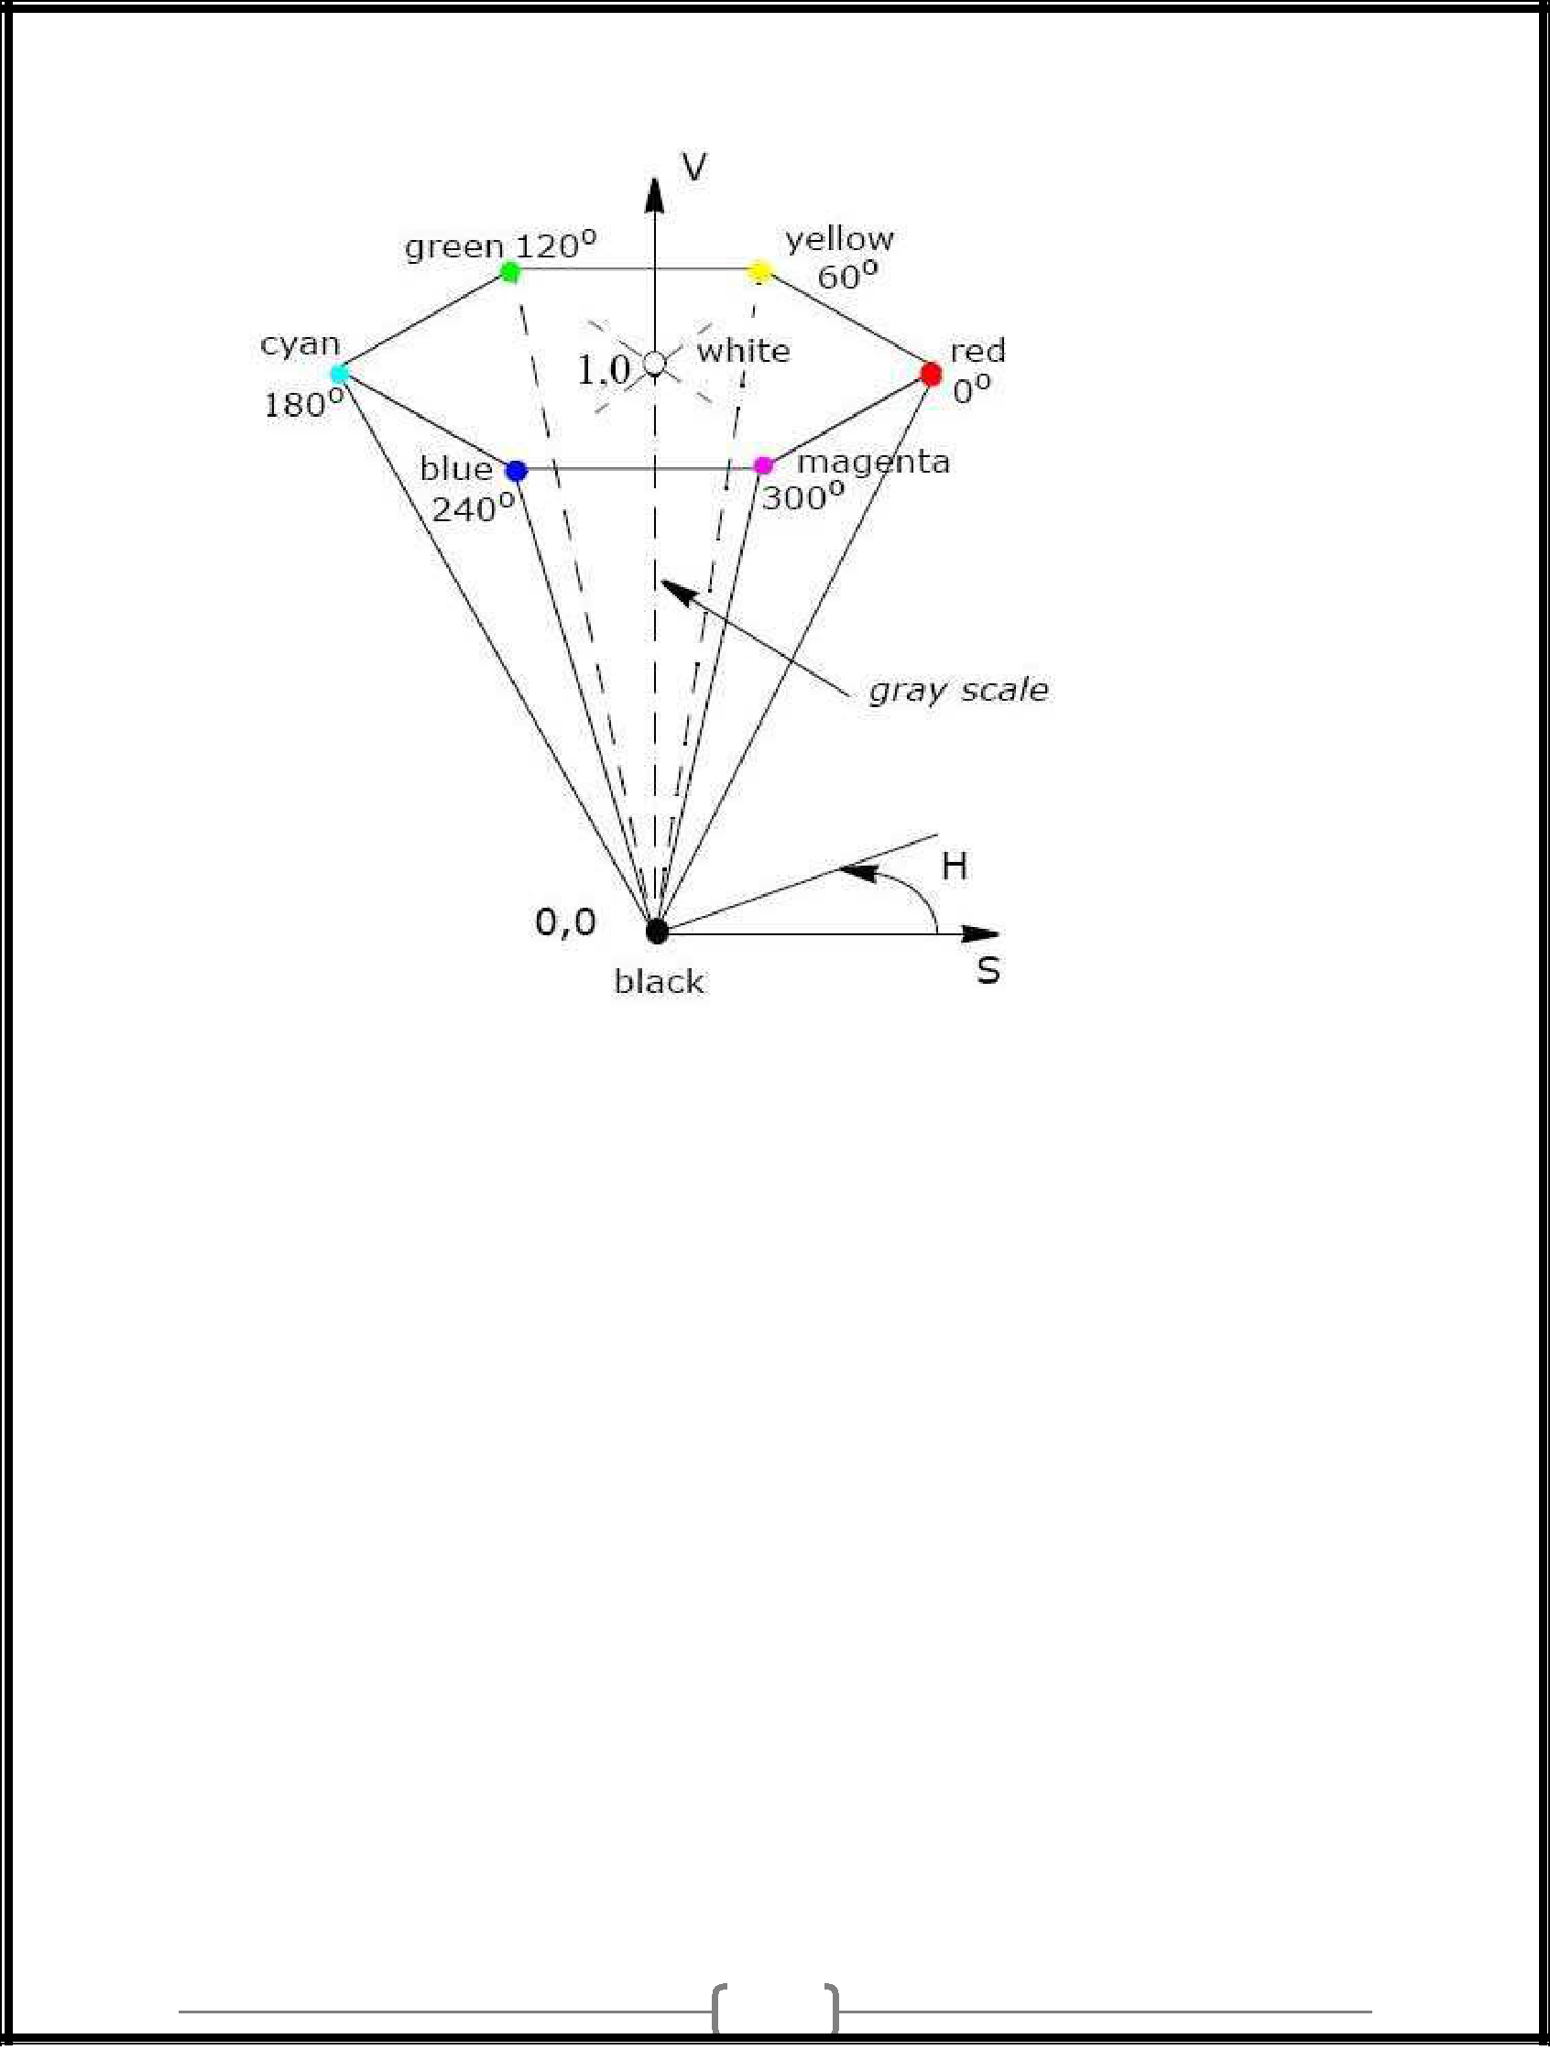

**2.3 PROPOSED APPROACH**

In our project we have done face detection using haar feature based cascade classifiers. Object Detection using Haar feature-based cascade classifiers is an effective object detection method proposed by Paul Viola and Michael Jones in their paper, “Rapid Object Detection using a Boosted Cascade of Simple Features” in 2001. It is a machine learning based approach where a cascade function is trained from a lot of positive images. It is then used to detect objects in other images. Here positive images refer to the fact that images that are there with faces.

Steps to use the haar feature based cascade classifiers:

1)The algorithm at first takes a lot of positive images(i.e. images with faces ).

2)we extract feature from these images ,each feature  is a single value obtained by subtracting sum of pixels under white rectangle from sum of pixels under black rectangle.

3)there are many features possible based on window size.

4)the opencv already has pretrained classifiers to detect different body parts like face, etc. We have used here the file which has the pretrained model available already for face detection .

5)Up until here we have done the part of creating /getting proper images for face detection but we need to recognize them too and for the purpose of recognition we have used artificial neural network.

6)  Training the Algorithm: First, we need to train the algorithm. To do so, we need to use a dataset with the facial images of the people we want to recognize(we created this dataset using haar based cascade classifiers as mentioned in above steps). We need to also set an ID (it may be a number or the name of the person) for each image, so the algorithm will use this information to recognize an input image and give you an output. Images of the same person must have the same ID.

7) This is most important step for our network. It consists of three parts -

1. Convolution
2. Polling
3. Flattening

The primary purpose of Convolution is to extract features from the input image. Convolution preserves the spatial relationship between pixels by learning image features using small squares of input data. Since every image can be considered as a matrix of pixel values. Consider a 5 x 5 image whose pixel values are only 0 and 1 (note that for a grayscale image, pixel values range from 0 to 255, the green matrix below is a special case where pixel values are only 0 and 1). Also, consider another 3 x 3 matrix. Then, the Convolution of the 5 x 5 image and the 3 x 3 matrix can be computed. The obtained matrix is also known as the feature map. An additional operation called ReLU is used after every Convolution operation. The next step is of pooling. Pooling (also called subsampling or downsampling) reduces the dimensionality of each feature map but retains the most important information. In case of Max Pooling, we define a spatial neighborhood (for example, a 2×2 window) and take the largest element from the rectified feature map within that window. Instead of taking the largest element we could also take the average (Average Pooling) or sum of all elements in that window. In practice, Max Pooling has been shown to work better.

After pooling comes flattening. Here the matrix is converted into a linear array so that to input it into the nodes of our neural network.

8)Full connection is connecting our convolutional network to a neural network and then compiling our network. Here we have made 2 layer neural network with a sigmoid function as an activation function for the last layer as we need to find the probability of the object being a human.

9)Data Augmentation: While training your data, you need a lot of data to train upon. Suppose we have a limited number of images for our network. What to do now??

You don’t need to hunt for novel new images that can be added to your dataset. Why? Because, neural networks aren’t smart to begin with. So to get more data, we just need to make minor alterations to our existing dataset. Minor changes such as flips or translations or rotations. Our neural network would think these are distinct images anyway. Data augmentation is a way we can reduce overfitting on models, where we increase the amount of training data using information only in our training data. The field of data augmentation is not new, and in fact, various data augmentation techniques have been applied to specific problems. Now we have a huge amount of data and its time for the training.

10) Training our Network: If you are training with a good video card with enough RAM (like an Nvidia GeForce GTX 980 Ti or better), this will be done in less than an hour. If you are training with a normal cpu, it might take a lot longer. With increasing number of epochs, the accuracy will increase.

Summary

So, we created a simple Image Recognition Classifier. The same concept can applied to a diverse range of objects with a lot of training data and appropriate network. You can change the dataset with the images of your friends and relatives and work upon the network to make a Face Recognition Classifier.

**3. Face Recognition**

**3.1 Introduction**

The recognition of face of human is challenging in computer-human interaction. The face is our essential center of consideration in societal life playing a critical part in assigning identification and emotion of the person. We can perceive various appearances adapted all through our lifespan and distinguish faces initially even following quite a while of detachment. This expertise is very vigorous notwithstanding of substantial varieties in visual boost because of evolving condition, maturing and diversions, for example, facial hair, glasses or changes in haircut.

Computational models of face acknowledgment are fascinating in light of the fact that they can contribute to hypothetical learning as well as to functional applications. PCs that identify and recognizes the face could be connected to a broad assortment of undertakings together with criminal recognizable proof, security framework, image and film handling, identity confirmation and human-PC interaction.

This project uses the principal component analysis (PCA) for face recognition. There are many other face recognition algorithm, but principal component analysis (PCA) based face recognition is the simplest one for face recognition

**3.2 Principal Component Analysis (PCA)**

**PCA** was invented by Karl Pearson in 1901. It involves the mathematical method totransforms an amount of probably interrelated variables into a numeral of unorganized variables is called the principal components. The transformation can be defined as that the first principal component has as high variance as it is possible and for every succeeding component.

**3.3 Neural Network As A Recogniser**

After extracting the features from the given face image, a recognizer is needed to recognize the face image from the stored database. This a recognition method, which uses two networks: Back Propagation Network (BPN) and Radial Basis Function Network (RBF) [10]. Back propagation can train multilayer feed-forward networks with differentiable transfer functions to perform function approximation, pattern association, and pattern classification. The BPN is designed with one input layer, one hidden layer and one output layer. The input layer consists of six neurons the the inputs to this network are feature vectors derived from the feature extraction method in the previous section. The network is trained using the samples. The Back propagation training takes place in three stages:

1. Feed forward of input training pattern

2. Back propagation of the associated error and

3. Weight adjustment.

During feed forward, each input neuron (p1) receives an input value and broadcasts it to each hidden neuron, which in turn computes the activation and passes it on to each output unit, which again computes the activation to obtain the net output. During training, the net output is compared with the target value and the appropriate error is calculated. From this, the error factor is obtained which is used to distribute the error back to the hidden layer. The weights are updated accordingly. In a similar manner, the error factor is calculated for units. After the error factors are obtained, the weights are updated simultaneously. The output layer contains one neuron. The result obtained from the output layer is given as the input to the RBF.

**4. Methodology and Design**

**4.1 System Design**

In this design, several related components in terms of functionality have been grouped to form sub-systems which then combine to make up the whole system. Breaking the system down to components and sub-systems informs the logical design of the class attendance system.

**4.2 General Overview**

The flow diagram depicts the systems operation.

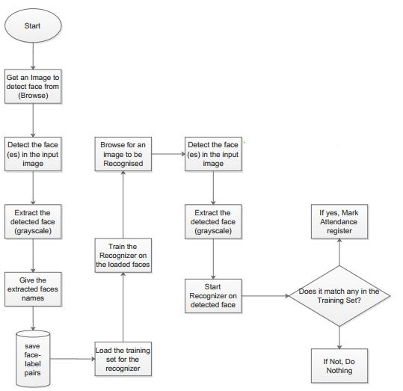

It can be observed that most of the components utilized are similar, (the Image acquisition component for browsing for input images, the face detector and the faces database for storing the face label pairs) only that they are employed at the different stages of the face recognition process.

**4.3 Training Set Manager Sub System**

The logical design of the training set management sub-system is going to consist of an image acquisition component, a face detection component and a training set management component. Together, these components interact with the faces database in order to manage the training set. These are going to be implemented in a windows application form.

**4.4 Face Recognizer Sub System.**

The logical design of the Face Recognizer will consist of the image acquisition component, face recognizer and face detection component all working with the faces database. In this the image acquisition, and face detection component are the same as those in the Training set manager sub system as the functionality is the same. The only difference is the face recognizer component and its user interface controls. This will load the training set again so that it trains the recognizer on the faces added and show the calculated eigen faces and average face. It should then show the recognized face in a picture box.

**4.5 System Architecture.**

The figure below shows the logical design and implementation of the three desktop subsystems.

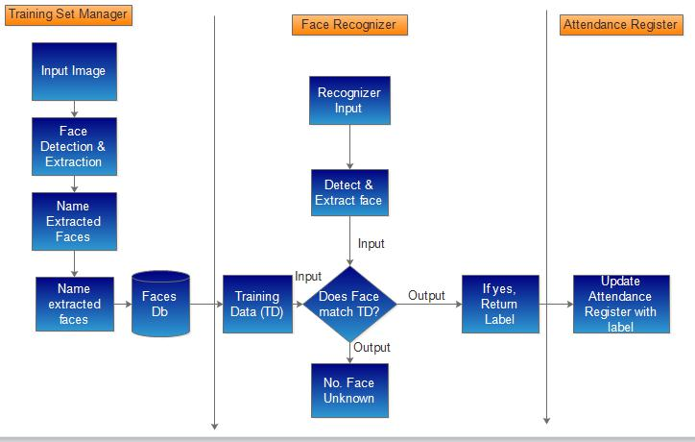

**3.7 Functions of the two Sub –Systems**

The functionalities of the components are depicted in the block diagrams. The face recognizer system will consist of two major components i.e. the training set manager and the face recognizer. These two components will share the Faces database, the image acquisition and the face detector components; as they are common in their functionality.

**5****. Experimental Screenshot**

**Graphical User Interface:**

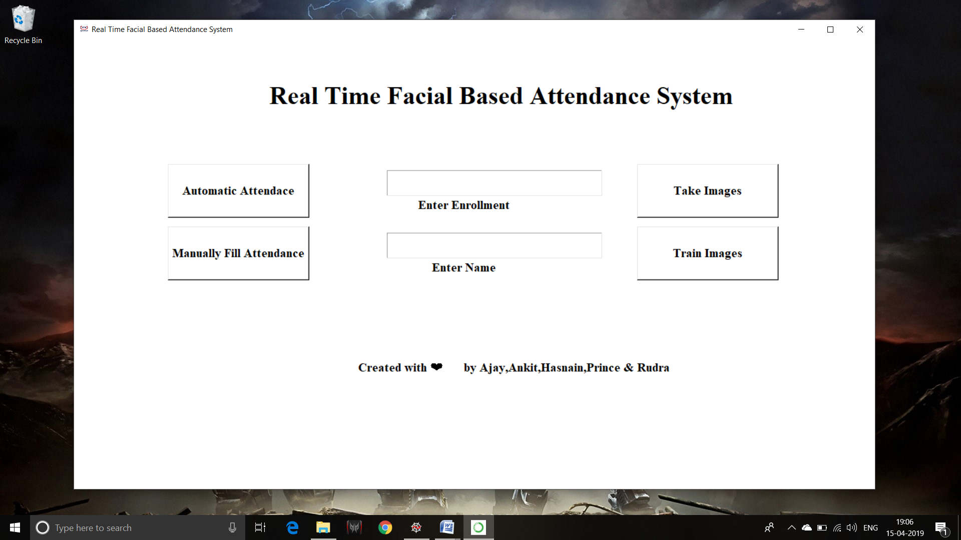

**Taking Image For Training:**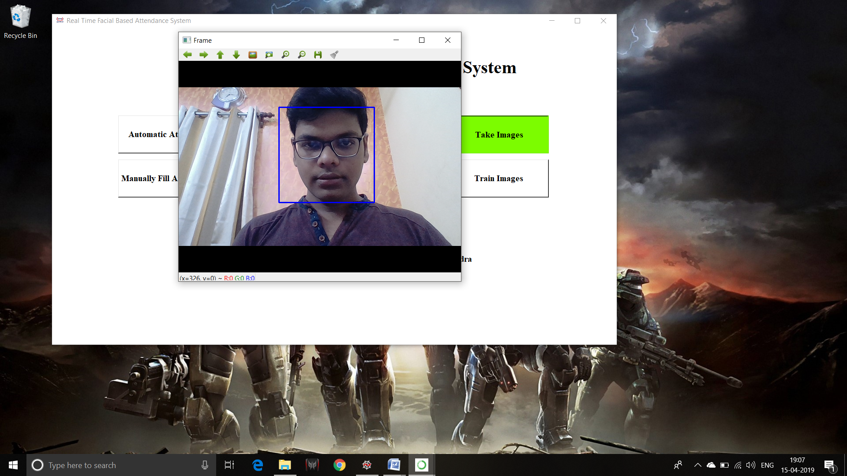

**Cropped Grayscale Image For Traing:**

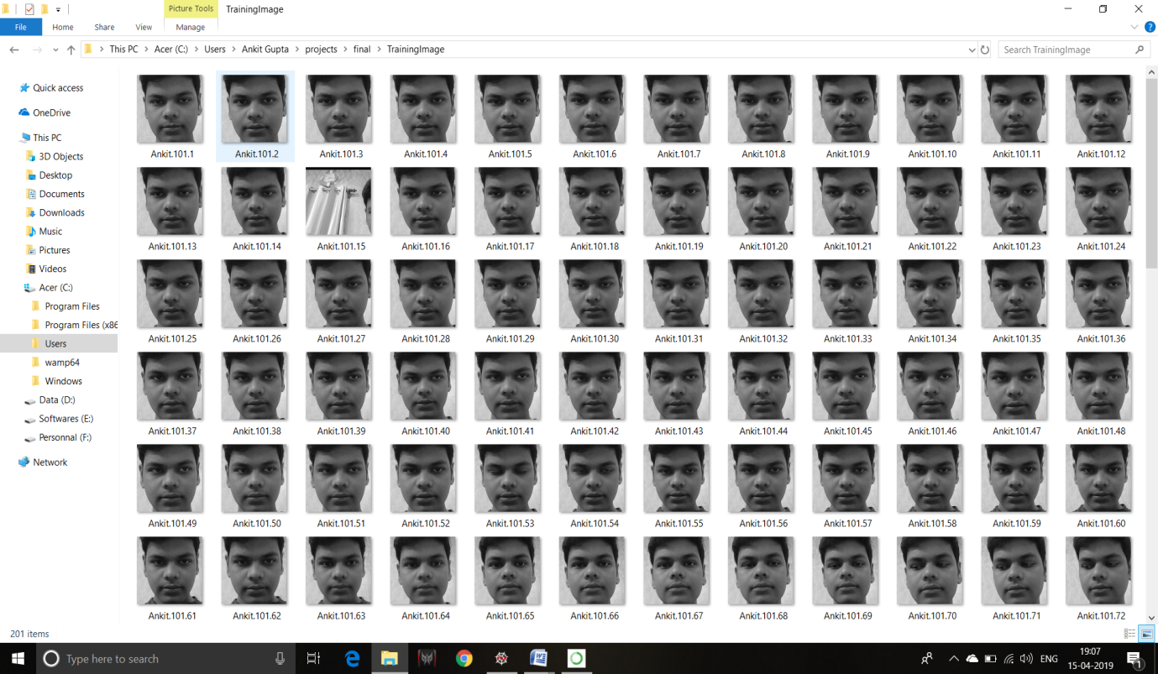

**Identifying faces In Real Time:**

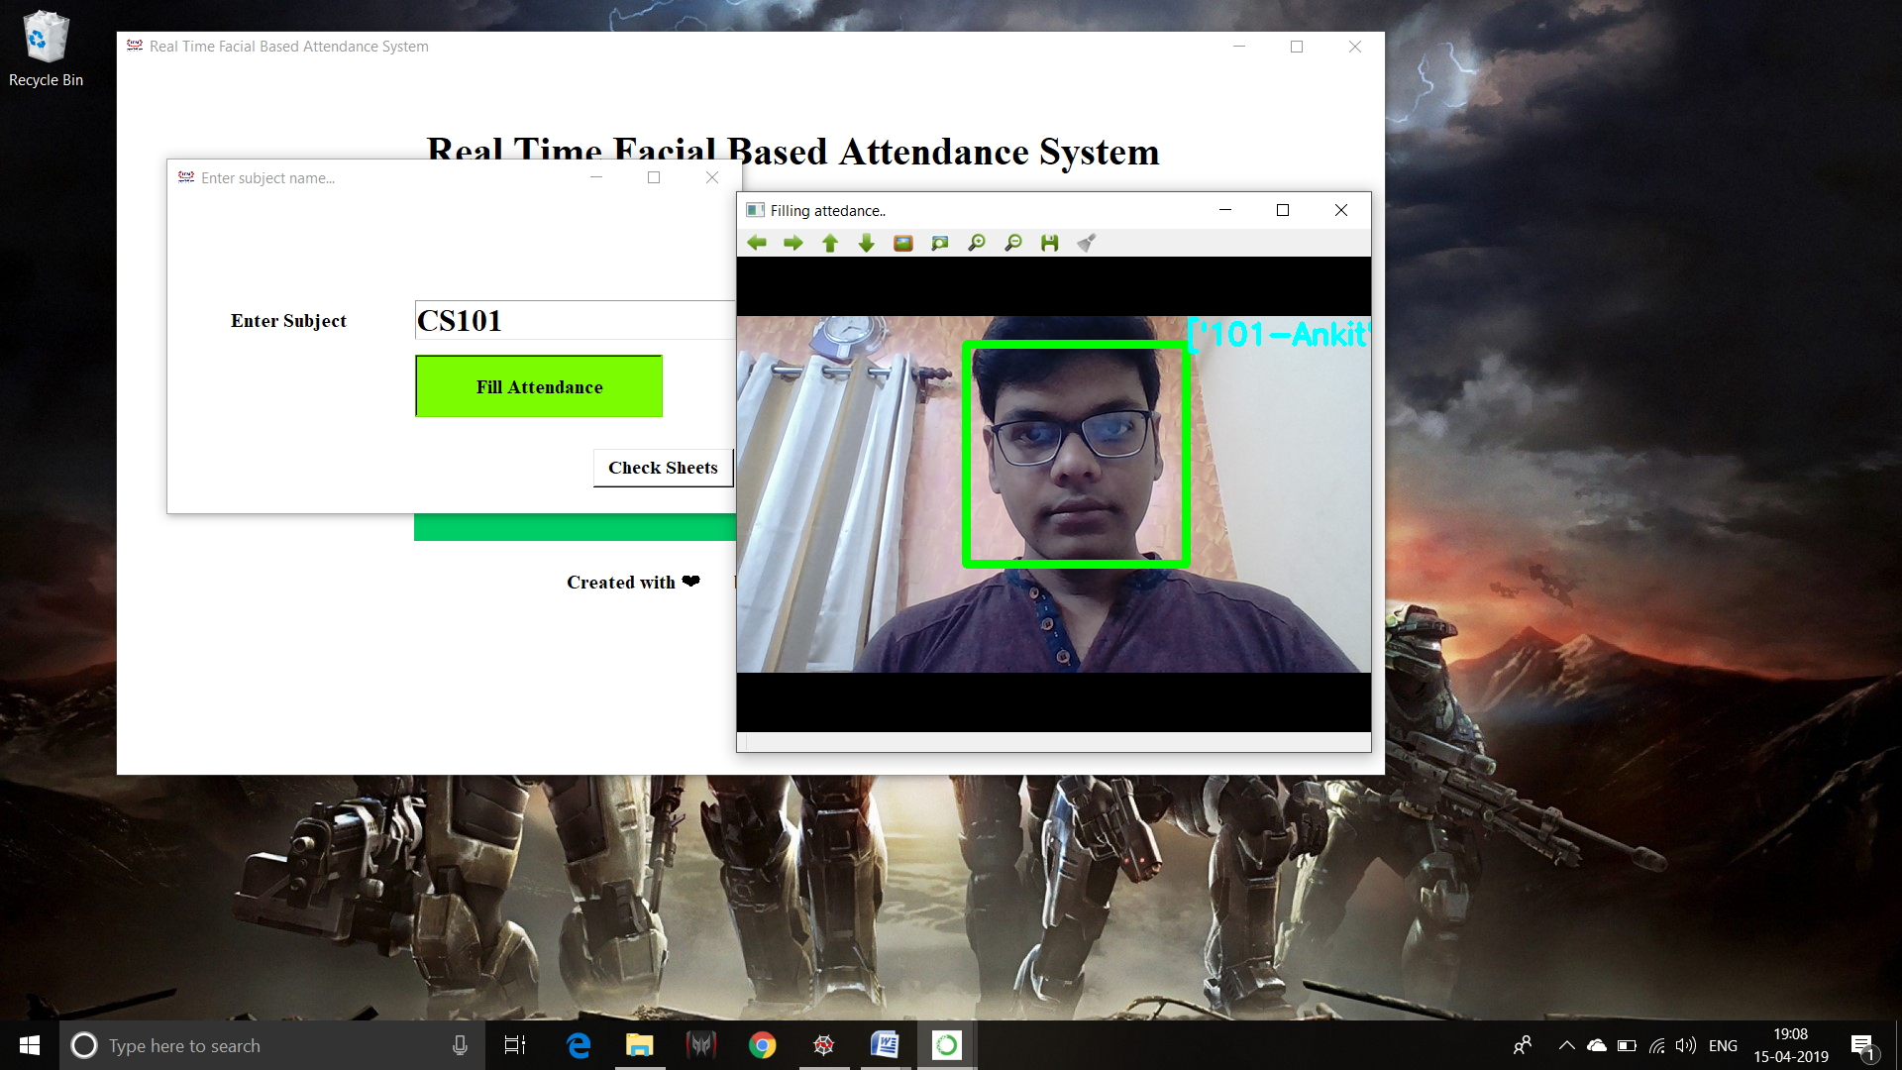

**6. Attendance Registering**

**6.1 Introduction**

Class attendance is very important aspects for the students studying in the colleges or schools. For an organization to be successful, it needs precise and quick method for recording the performance of the individuals inside this organization. Attendance gives the data of the individual whether that particular person is physically present or absent. The traditional method of calling roll number or name of the student for marking attendance is time consuming or wastage of time during the class hour.

In this project an automated student attendance system is made, which is based on face recognition. The recognized face of the individual is used for marking the attendance.

**6.2 Creating Attendance Sheet**

As the database contain images of five students, so the attendance sheet should contain name of the five students. The 7 x 4 cell array is created which contain the name of the nine students as shown in the figure

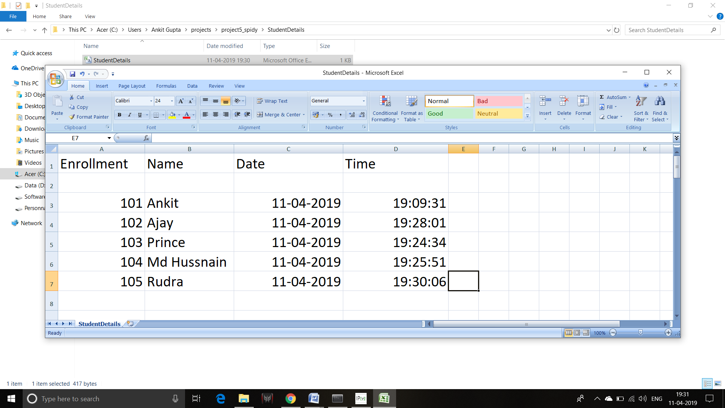

**6.3 Marking Attendance of the Student**

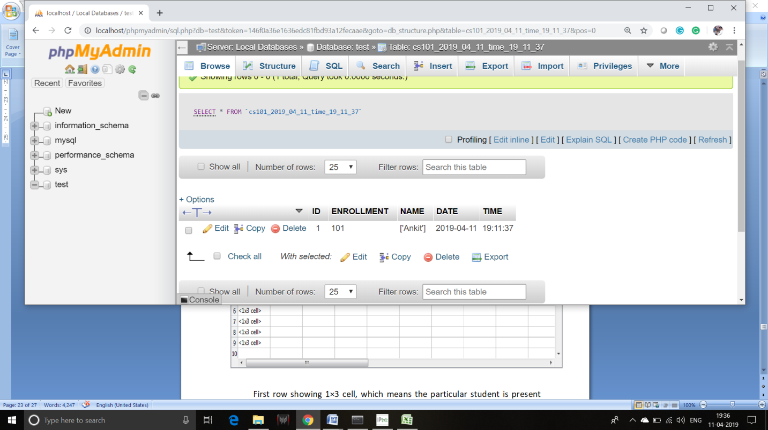When the face of the particular student is recognized, attendance is marked for that student for that particular day. If some students are absent then no attendance is marked for them. For attendance marking in each cell contain name of the student, and attendance is marked for the student. The attendance sheet is stored in the variable name data. Consider the second name stored in the cell array i.e., Ankit. When Ankit is recognized for let’s say five times i.e, one in each day then attendance is marked five times for that particular student. The particular case is shown in figure 16. Like this other student attendance is marked according to their presence in that particular day.

**7. Conclusion**

It can be concluded that a reliable, secure, fast and an efficient class attendance management system has been developed replacing a manual and unreliable system. This face detection and recognition system will save time, reduce the amount of work done by the administration and replace the stationery material currently in use with already existent electronic equipment.

There is no need for specialized hardware for installing the system as it only uses a computer and a camera. The camera plays a crucial role in the working of the system hence the image quality and performance of the camera in real time scenario must be tested especially if the system is operated from a live camera feed.

The system can also be used in permission based systems and secure access authentication (restricted facilities) for access management, home video surveillance systems for personal security or law enforcement.

**8. Future Work**

The major threat to the system is Spoofing. For future enhancements, anti- spoofing techniques like eye blink detection could be utilized to differentiate live from static images in the case where face detection is made from captured images from the classroom. From the overall efficiency of the system i.e. 83.1% human intervention could be called upon to make the system foolproof. A module could thus be included which lists all the unidentified faces and the lecturer is able to manually correct them.

Further work can be done on this project to alert the student by sending SMS regarding the attendance. For this purpose GSM module can be used. SMS alert can be given to the parent of the student

Future work could also include adding several well-structured attendance registers for each class and the capability to generate monthly attendance reports and automatically email them to the appropriate staff for review.

**9. References**

[1] Bhumika G. Bhatt, Zankhana H. Shah “Face Feature Extraction Techniques: A Survey”, National Conference on Recent Trends in Engineering & Technology, 13-14 May 2011.

[2] G. Yang and T. S. Huang, “Human face detection in complex background,” Pattern Recognition Letter, vol. 27, no.1, pp. 53-63, 1994.

[3] E. Saber and A.M. Tekalp, “Frontal-view face detection and facial feature extraction using color, shape and symmetry based cost functions,” Pattern Recognition Letters, vol. 17, no. 8, pp. 669-680, 1998.

[4] M. Turk, A. Pentland, Eigenfaces for Recognition, Journal of Cognitive Neurosicence, Vol. 3, No. 1, Win. 1991, pp. 71-86

1. Discriminant analysis for recognition of human face images Kamran Etemad and Rama Chellappa

[6] Jose M.Chaves-Gonzalez, Miguel A Vega-Rodriguez,Juan A.Gomez-Pulido,Juan M.Sanchez-perez,” Detecting skin in face recognition systems: A color spaces study”, Digital signal processing, 20(2010) 806-823.